TO: Junior Horse Show Participants
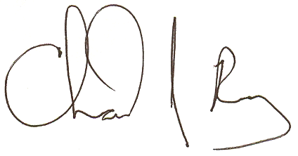

From: Chad J. Ray, Extension Agent Tom Devine, Extension Agent
4H & Youth Development Livestock

DATE: February 22, 2022

RE: 2022 KATHY NORMAN MEMORIAL JUNIOR HORSE SHOW

The Junior Horse Show will be Saturday, April 9th at 10:00 am at the McDowell Saddle Club Show Grounds on Highway 226 South off I-40. Rain Date: April 10th at 1:00 pm

The show is sponsored by the McDowell Agricultural Youth Foundation, United Fund, Farm Bureau-McDowell, and McDowell County businesses.

Premier Exhibitor prizes will be mailed to the address on the entry forms. Winnings not claimed within 30 days of awarding will be forfeited.

Enclosed are the rules, list of classes, and premiums. Pre-registration is required and due by March 21st. All entries must be complete and entered on an official form. You may make additional copies as needed. There will be an entry fee of $5 per class. Exact change would be appreciated. Make checks payable to: McDowell Agricultural Youth Foundation. No entries past March 21st.

We hope the information provided in this packet will help you prepare for this year's show. If you have any questions, or need to check on the show status in case of inclement weather, feel free to call the Cooperative Extension Office at 652-8104. Hope to see you at the show!

*****We MUST have a minimum of 10 exhibitors signed up for the show. If we do not have 10 we will hold a fun show instead and not charge entry fees. In this event we will not have a premier exhibitor but will award fun prizes*****

